TG-51 Worksheet B: Electron Beams - Cylindrical Chambers

For electrons with R₅₀ ≥ 2.6 cm (energies > 6MV) only and preferably ≥ 4.3 cm (10MeV).

- Site data
Institution:
Physicist:
Date:
Accel Mfr:
Model & serial number:
Nominal electron energy/beam identifier: MeV

- Instrumentation
a. Chamber model:
Serial number:
Cavity inner radius (r_{cav}, Table III): cm

Waterproof: yes no

If no, is waterproofing ≤ 1 mm PMMA or thin latex?: yes no

b. Electrometer model:
Serial number:
i. P_{elec}, electrom. corr factor (Sec.VII.B): C/C or C/rdg.
c. Calibration Factor 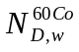(Sec.V): Gy/C (or Gy/rdg)
Date of report (not to exceed 2 years):

3. Measurement Conditions (centarl axis of chamber at d_{ref}, Sec. X.A)
a. Distance SSD: cm
b. Field Size on surface: cm²
c. Number of monitor units: MU

- Beam Quality (Sec.VIII.C)
Measure I₅₀ by measuring depth-ionization curve and, for cylindrical chambers only, shifting curve upstream by 0.5 r_{cav}
I₅₀: cm
a.i. If 2 ≤ I₅₀ ≤ 10 cm:
R₅₀ = 1.029I₅₀ - 0.06 cm
ii. If I₅₀ > 10 cm:
R₅₀ = 1.059I₅₀ - 0.37 cm
b. Reference depth d_{ref} = 0.6R₅₀-0.1 cm (water equivalent)

- Determination of 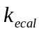 and 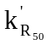
Chamber mode used to get k_{ecal}:
a. [Table III]
b. i. from figures [Fig 5 or 7]
or ii. from analytic expression for Farmer-like cylindrical chambers
: = 0.9905 + 0.071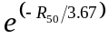 [Eq.(19) 2 ≤ R₅₀ ≤ 9 cm]
TG-51 Worksheet B: Electron Beams - Cylindrical Chambers ( cont).

6. Temperature /Pressure Correction (Sec.VII.C)
a. Temperature: °C
b. Pressure: 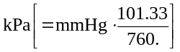
c.P_{TP}: 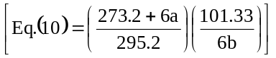
7. Polarity Correction (Sec.VII.A)
M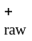: C or rdg
M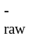: C or rdg
a. M_{raw} (for polarity of calibration): C or rdg
b. P_{pol}: 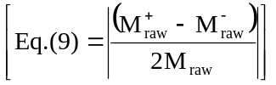
- P_{ion} measurements (Sec.VII.D.2)
Operating voltage= V_{H}: V
Lower voltage V_{L}: V
M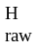: C or rdg
M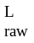: C or rdg
P_{ion} (V_{H}) (pulsed/swept beam, Eq.(12)): 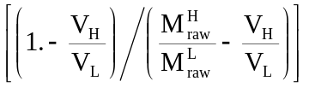
If P_{ion} > 1.05, another ion chamber should be used.

9. Corrected ion. ch. rdg M (Sec.VII) at d_{ref}

Fully corrected M (Eq (8)): C or rdg

10. Dose to water at reference depth, d_{ref} :

a. 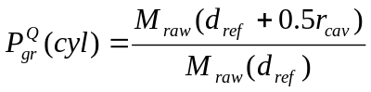

b. Dose to water at d_{ref} = Gy
Gy/MU
c. Dose / MU at d_{ref} = [10b/3c]

11.Dose to water / MU at dmax (if relevant locally)
a. %dd(d_{ref}) as used clinically:
b. Dose / MU at dmax= Gy/MU[10c/(11a/100)]

